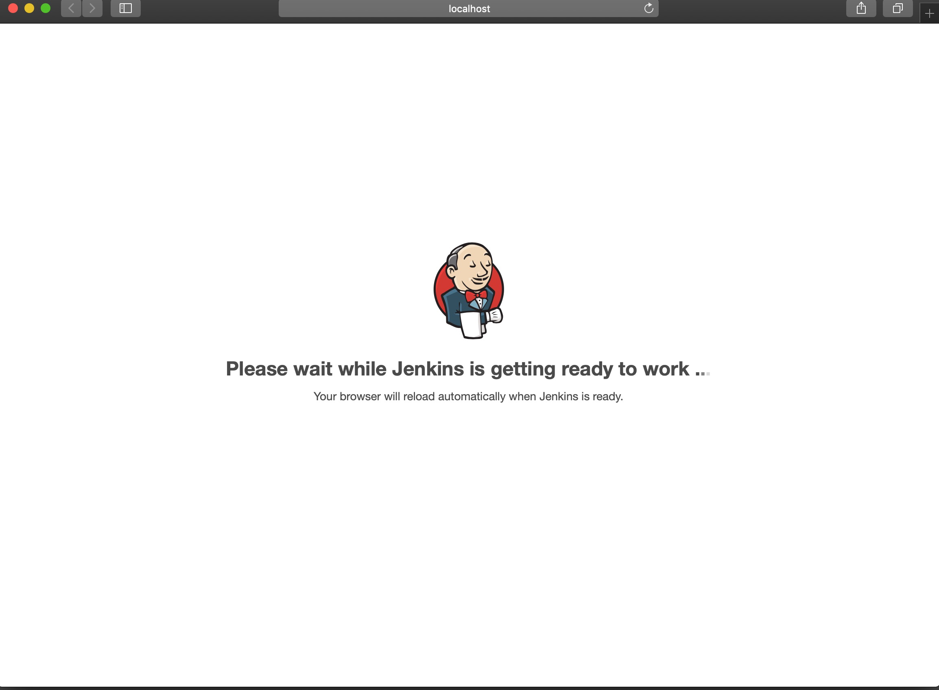

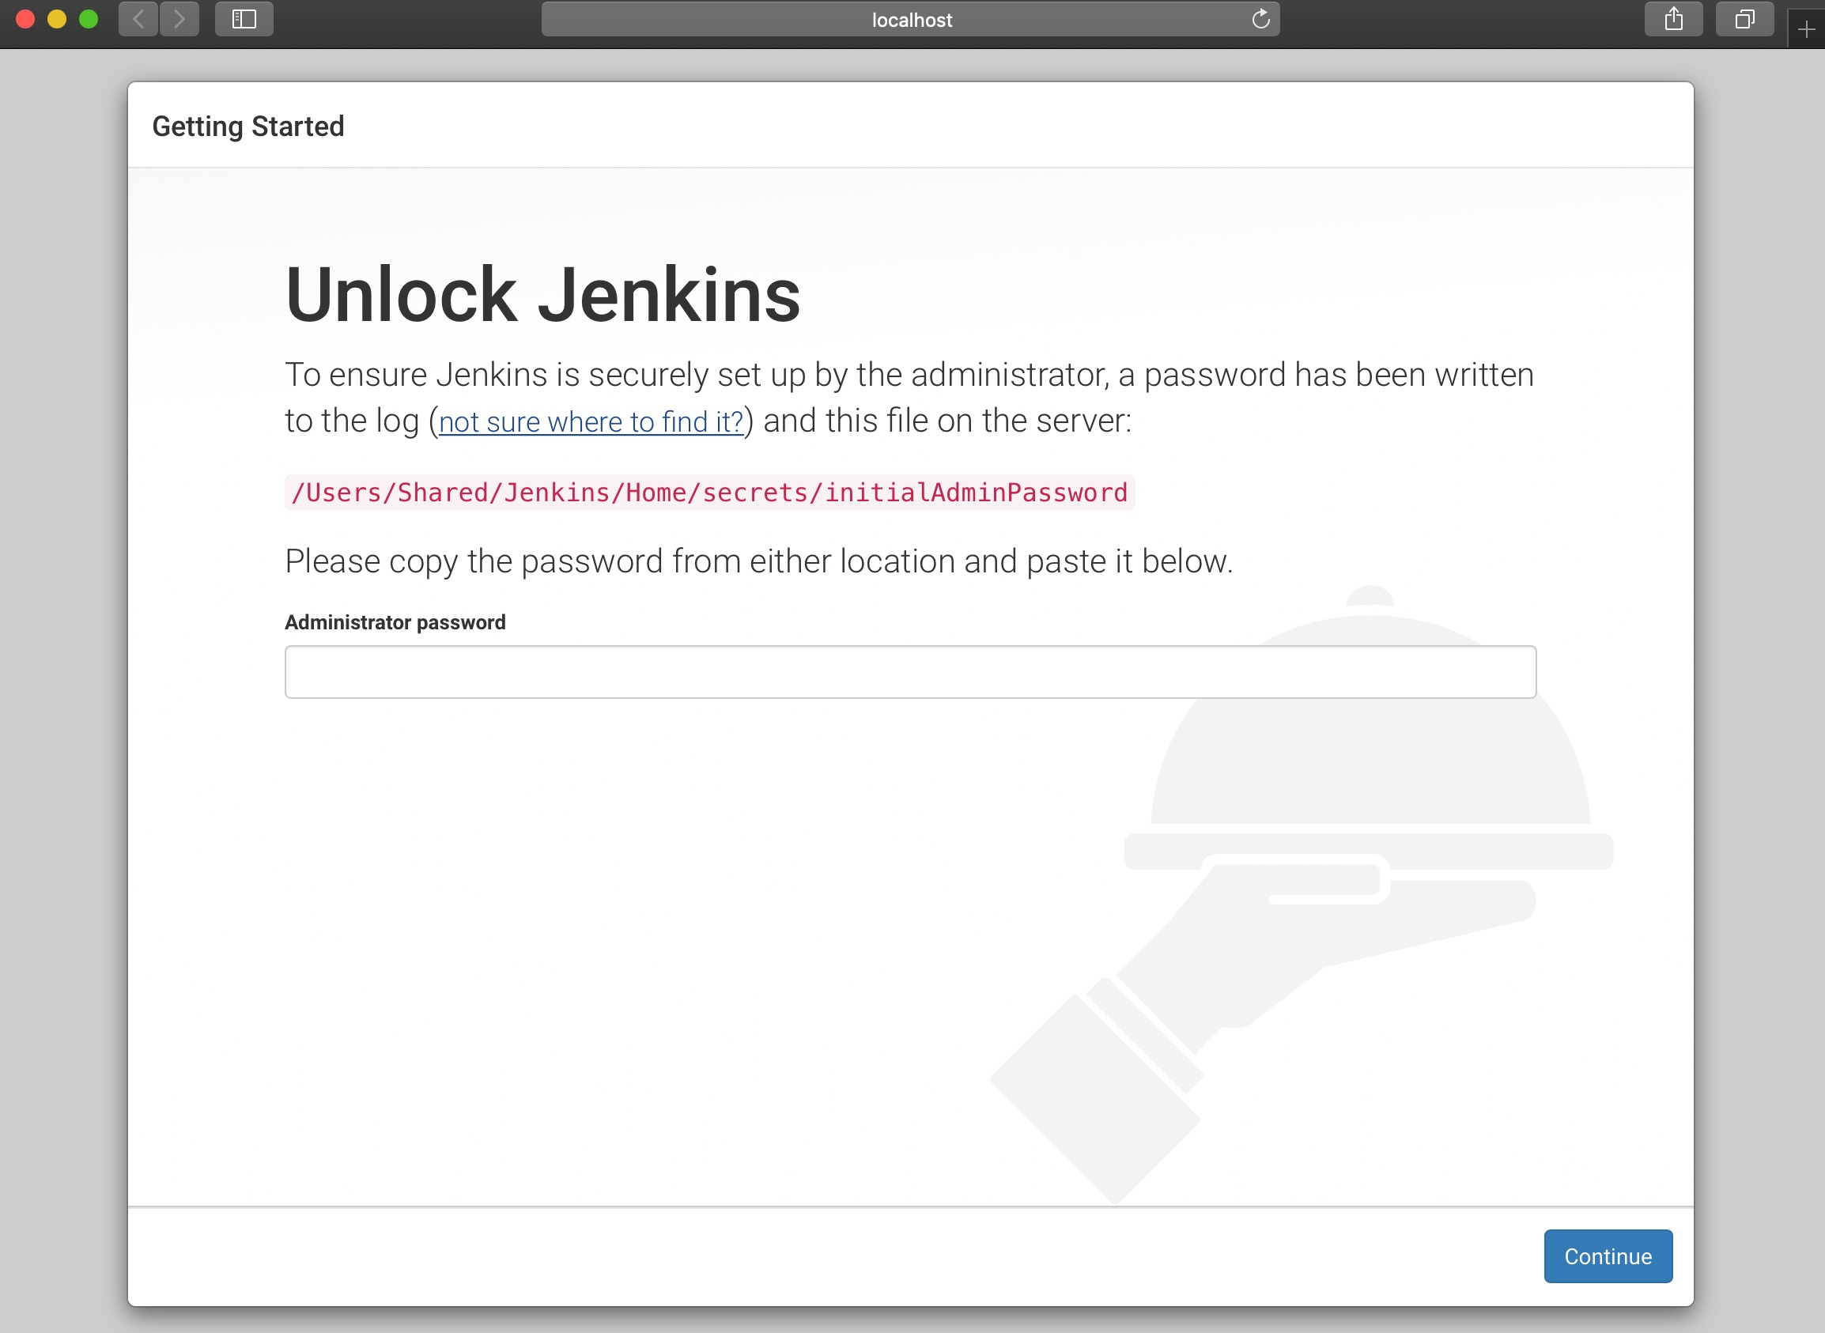

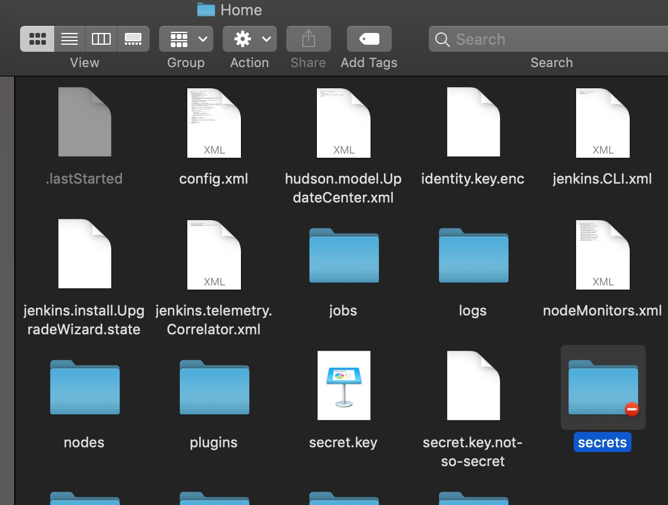

Right click on the Secrets folder as highlighted above, get info, bottom of get info dialog, click on the lock icon

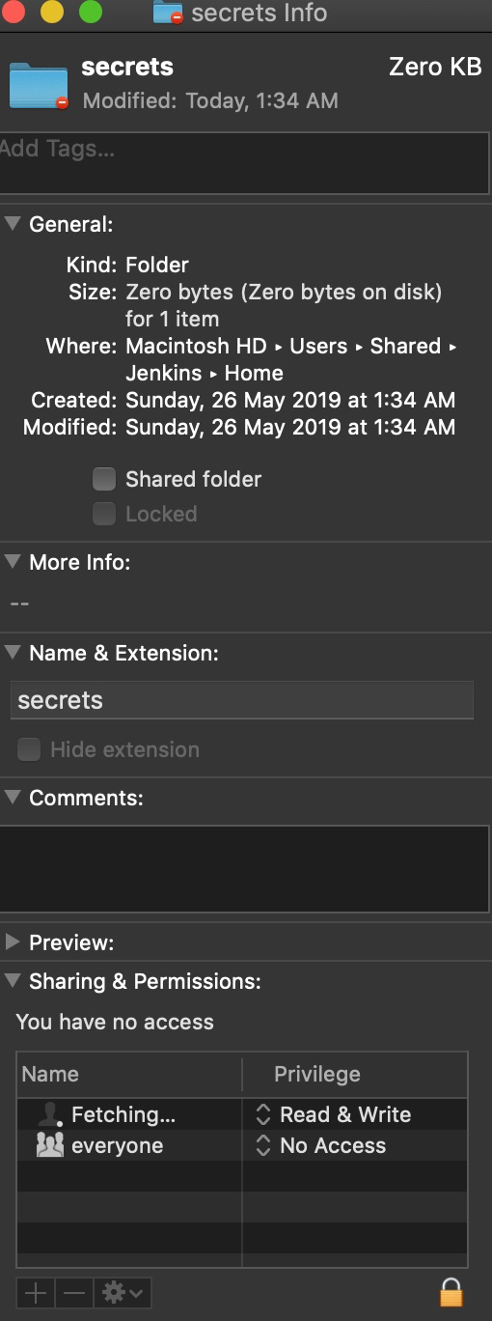

enter the system password
add the current user by clicking on the + icon to extreme left to lock icon
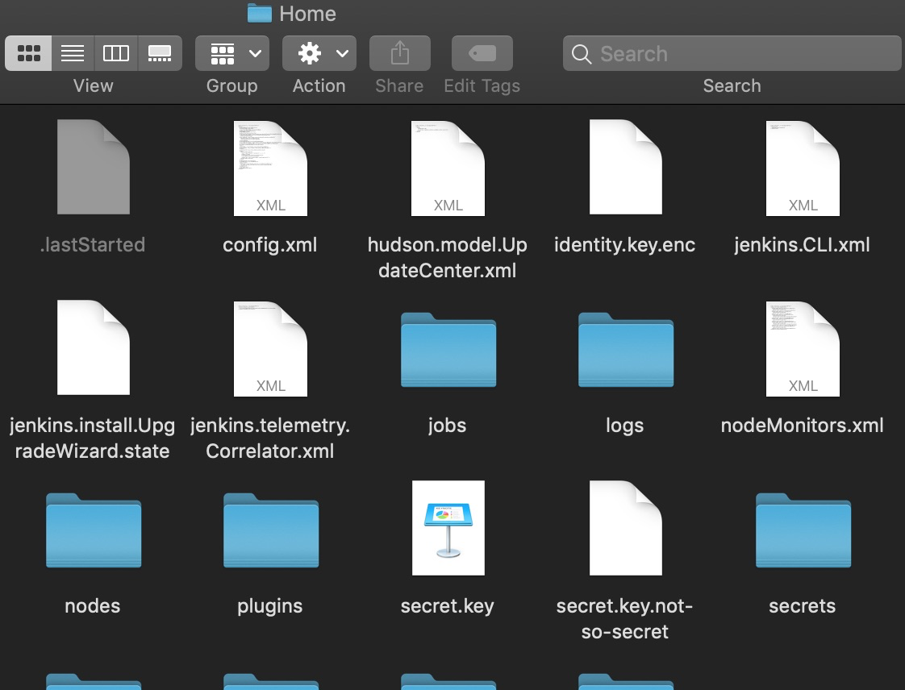

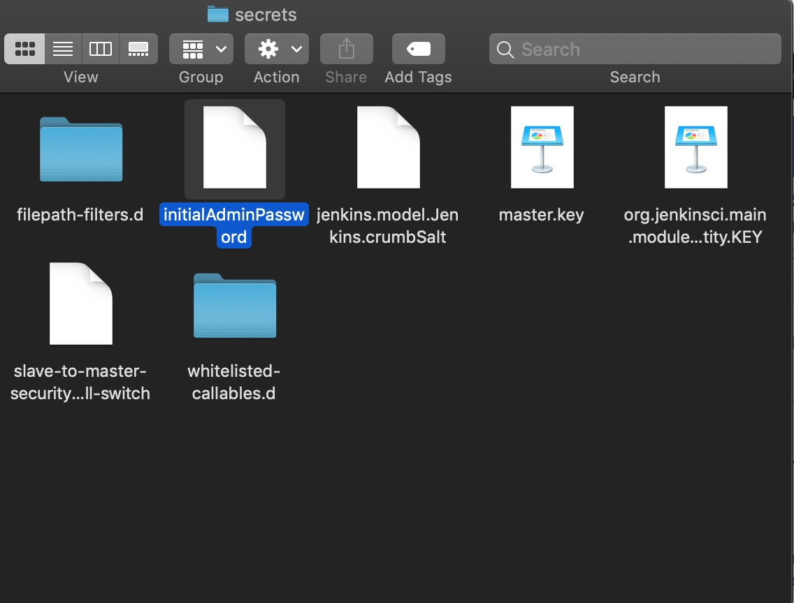

open the file n copy the key and paste to the password field of Jenkins local host web app

now right click on the initialadminpassword file and repeat the above steps to have access on the get info and open using textedit it to get the key

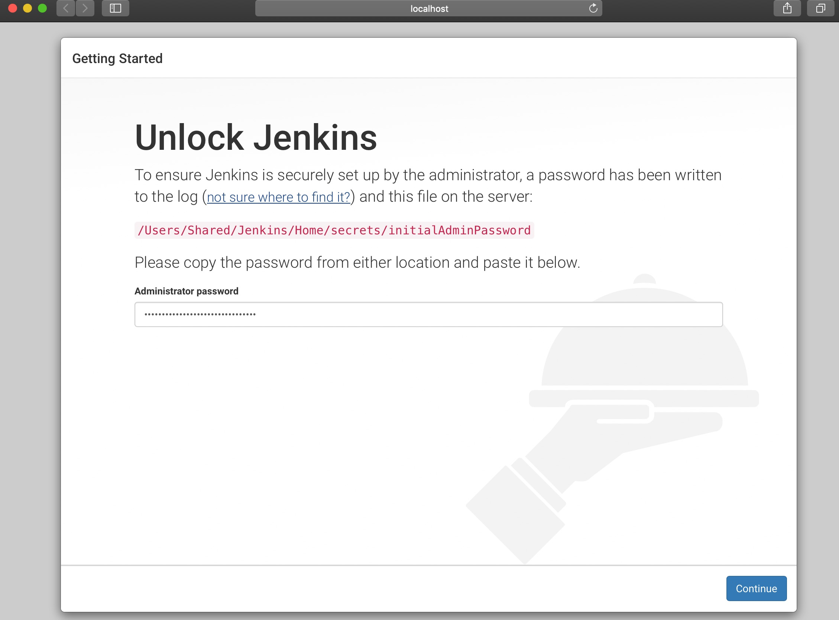

click on continue
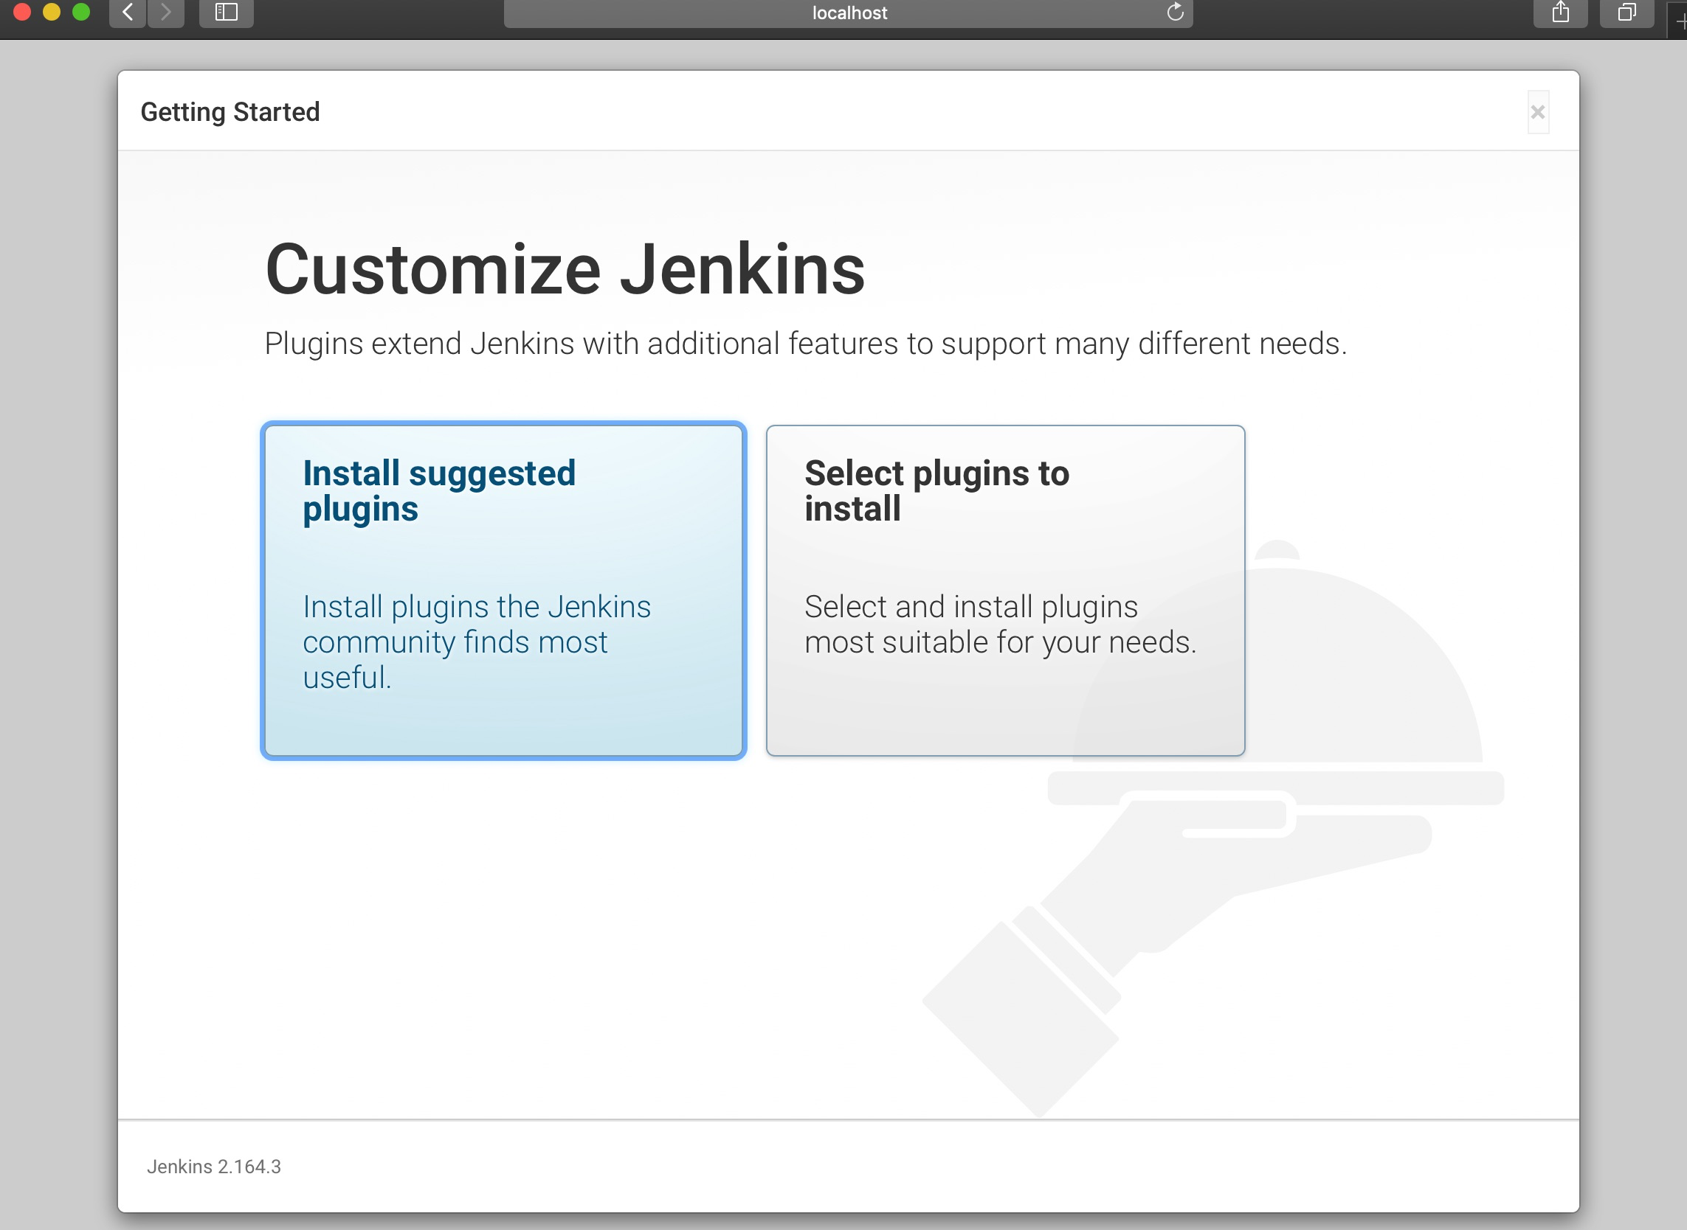

install suggested plugins – takes some time
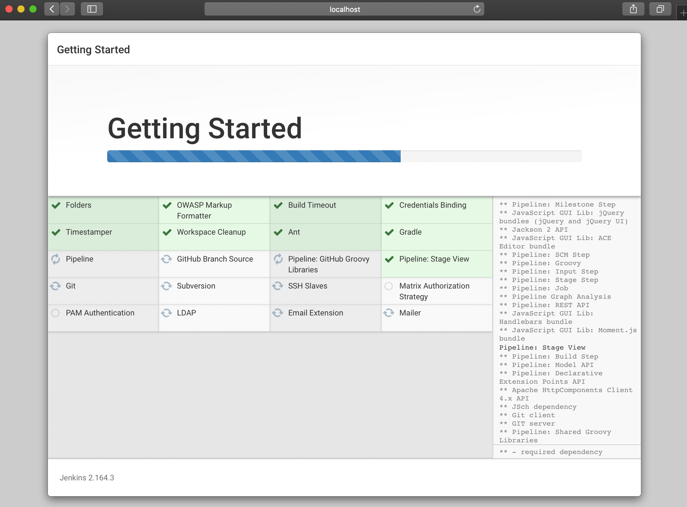

then next screen appears

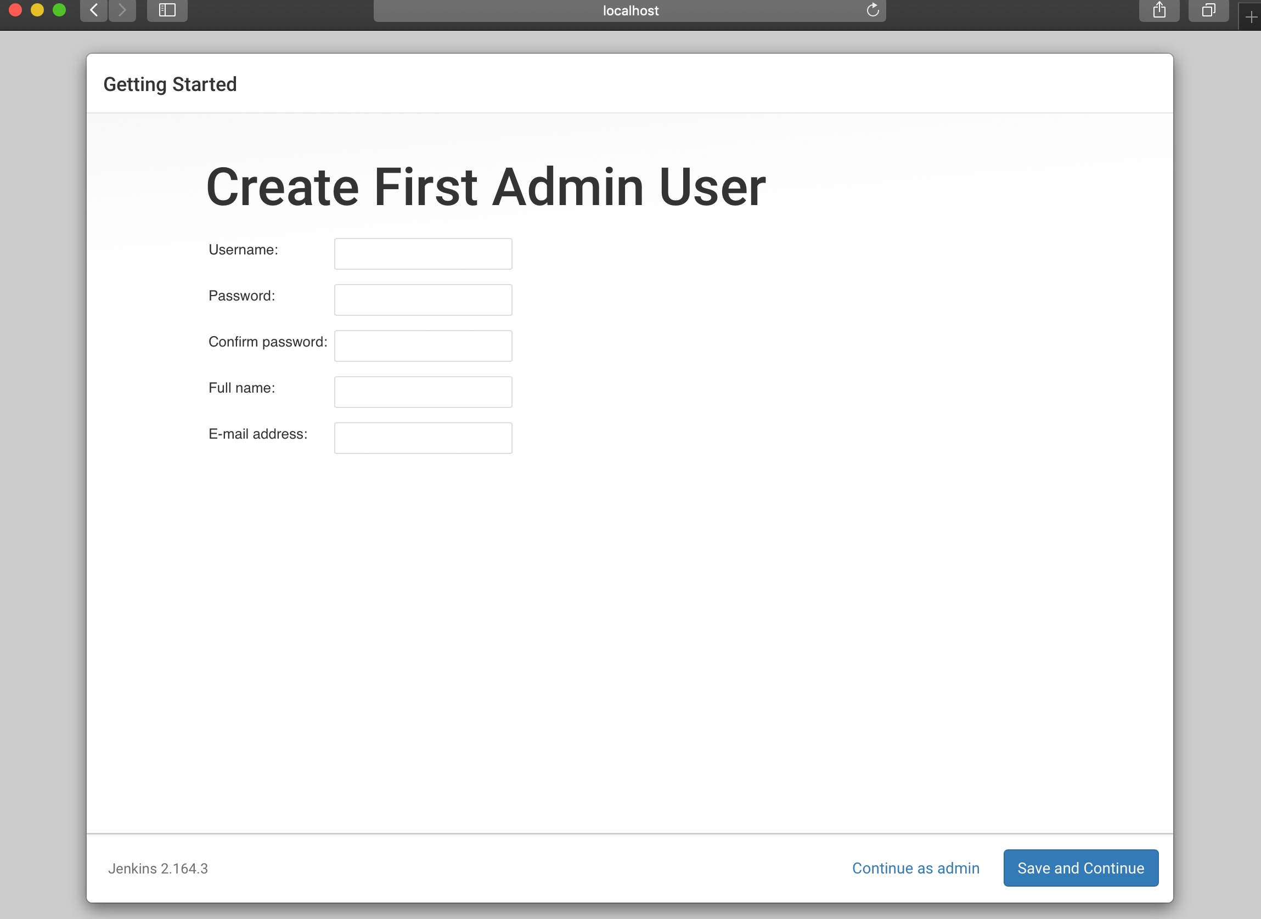

enter details and get this below screen to start

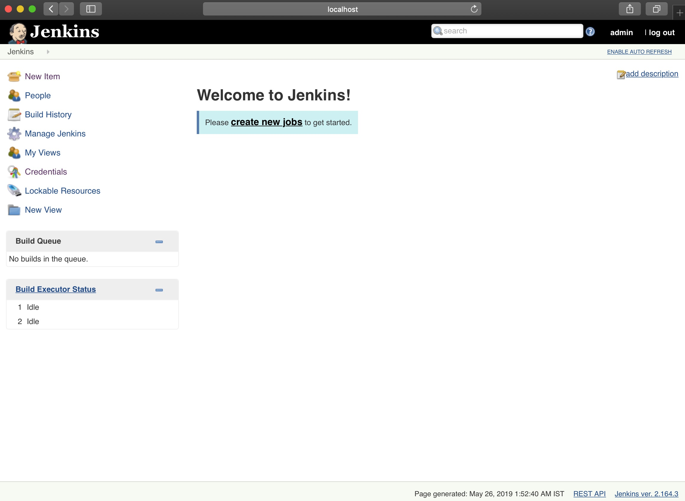

Maven setup Steps
- Manage plugin
- Search and Install Maven integration

Configure Jenkins tools
- Navigate to http://localhost:8080/configureTools/
- Add maven path
- Add JDK installation path
- Save

